Node Js

Init

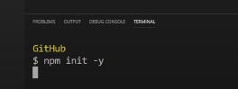

Basic init of project

Change main value

Basic express server start

* npm i express ejs express-ejs-layouts

Dev depend

npm I –save-dev nodemon

* package,json
* make changes to script

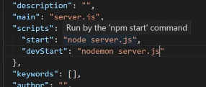

SETUP SERVER

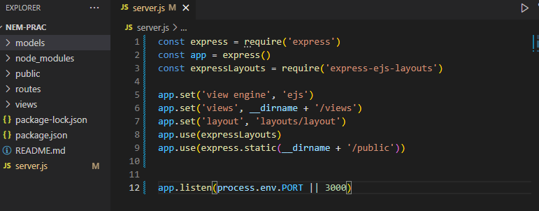

* now we have to set up routes for index.js (default when no add give)
* mongo db 
* 